Kenny Saldana

CIS 14A / JavaScript

**Overview**

There were three projects that were assigned for implementing various JavaScript coding. The goal for each project was to utilize the vast functionality of JavaScript with respect to HTML. To design each page accordingly and to present webpages that took advantage of these unique features.

It has been an overwhelming task, in my opinion, but valuable aspects that involve JavaScript and the enormous libraries and functionality that can be found within JavaScript. The reason I say overwhelming is the fact that such features can convolute the idea behind the designing aspect. A sort of lost in translation, where the main idea can be lost and/or the features are not implemented to their full extent. When designing these projects, you begin to really understand such features and their uses and how you can further improve on past functionality. In other words, I kept going back to improve the coding that was done whenever a better functionality could be used or to further streamline the overall aspect of the project. To this date, I’m realizing the vast improvements that still can be made to the three projects, but have improve tremendously since its beginning.

--------------------------------------------------

Public server information:

209.129.8.3

port 10000

SSH/SFTP

user: 47925 pw: 47925cis14a

--------------------------------------------------

**Start Here!!!**

**Karate Project Redesign**

**Survey Project**

**Personal Project**

I designed this project with two elements in mind, admiration of early California Custom cars and photography. I wanted to capture those two passions I have in website format.

I started with a previous project from a previous class I have taken, CIS 72A (HTML). The goal would be to improve on the format and implement the vast functionality of JavaScript. In theory, take advantage of the vast libraries within JavaScript and to build upon those building blocks.

One significant problem I encountered is the many ways in which to approach and apply these elements. The desirability for efficiency and effeteness, though it may not always be the case. There were certain characteristics and behavior when using JavaScript and the profound complication this project can become. Another aspect I wanted to capture is a “less is more” factor, not to have a cluttered webpages and unnecessary items.

1. Homepage

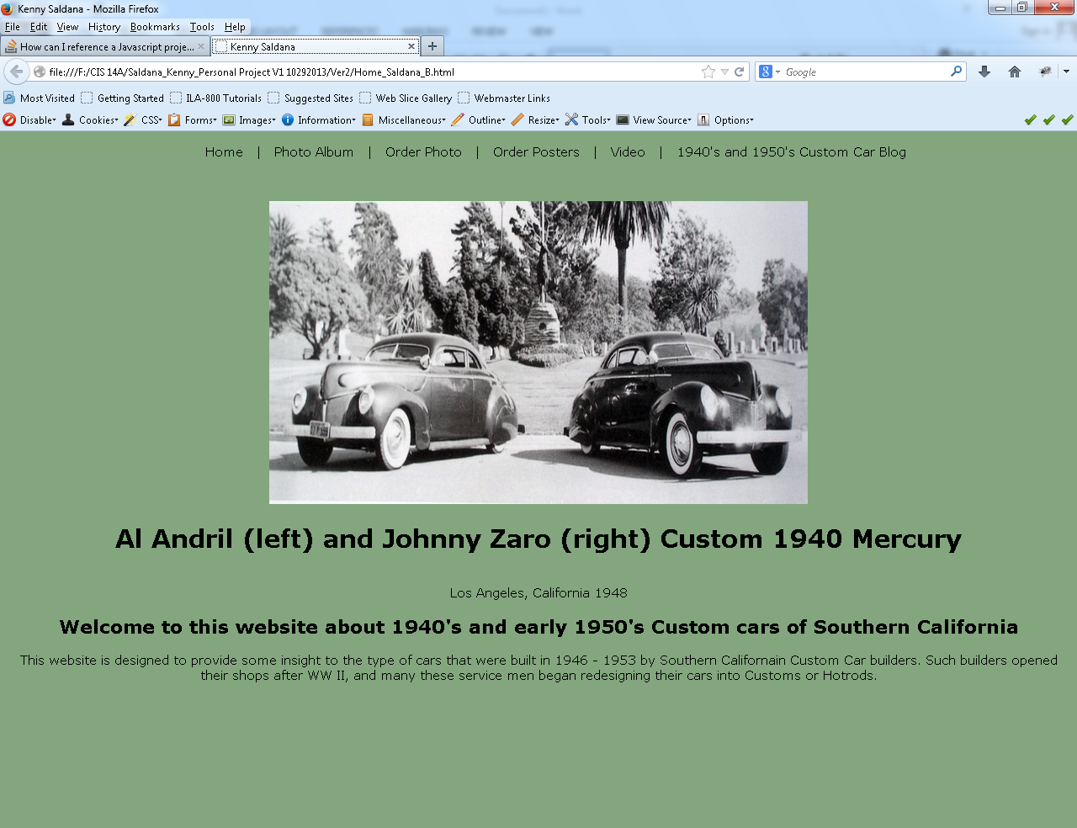

This was designed with simplicity and a focal point for the user. A brief description is given and the main links are place on the top and centered. No JavaScript was utilized for this design. A CSS file was used to handle the overall presentation of the webpage.

1. Photo Album

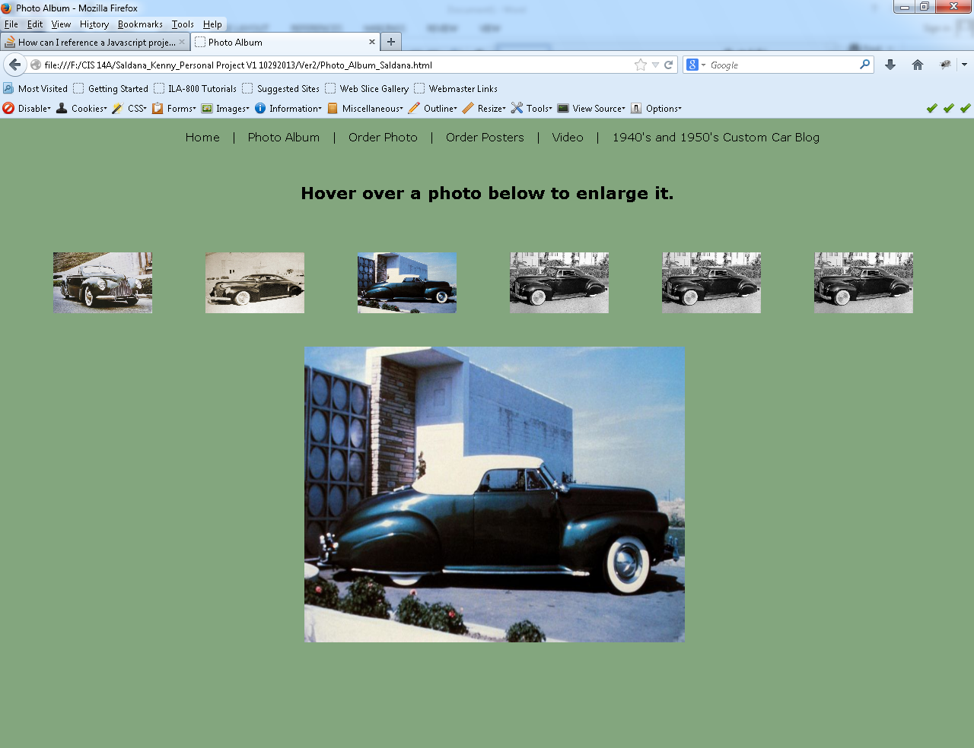

This webpage was designed in the same fashion as the Homepage. Again, I did not utilize JavaScript for the design of this page. However, I utilized the CSS file to handle the presentation of this page. One aspect I utilized was the mouse/pointer hoover over each photo to display a larger view of that particular photo. This page would present the idea behind the type of photos offered for purchase and a more thorough detail of a particular photo that may be purchased.

1. Order Photo

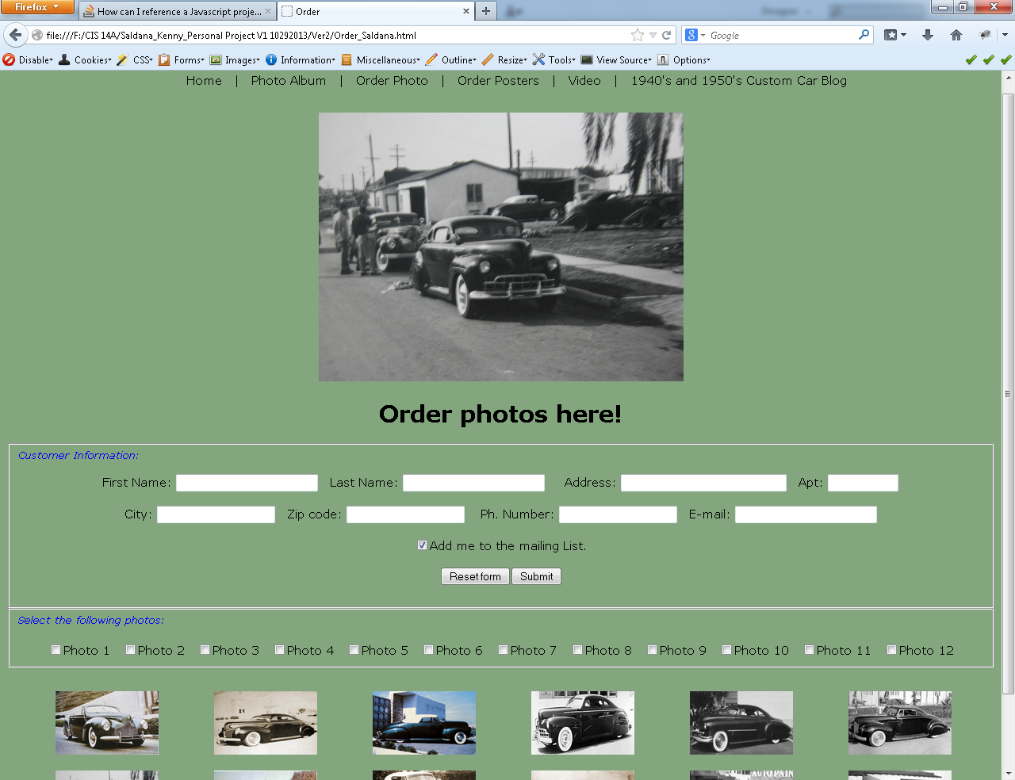

This webpage and the entire series of webpages are presented in the same format. This webpage was designed with JavaScript to handle the form validation. The customer needs to provide the necessary information when purchasing any item from this page. Each field is validated for correct format prior to submission. The customer can select any multiple photos displayed on this page.

Also, another CSS file is used to handle the presentation of this particular webpage. Due to its unique layout in terms of the images and the form fields, this allowed for a more harmonious view and layout of each particular field.



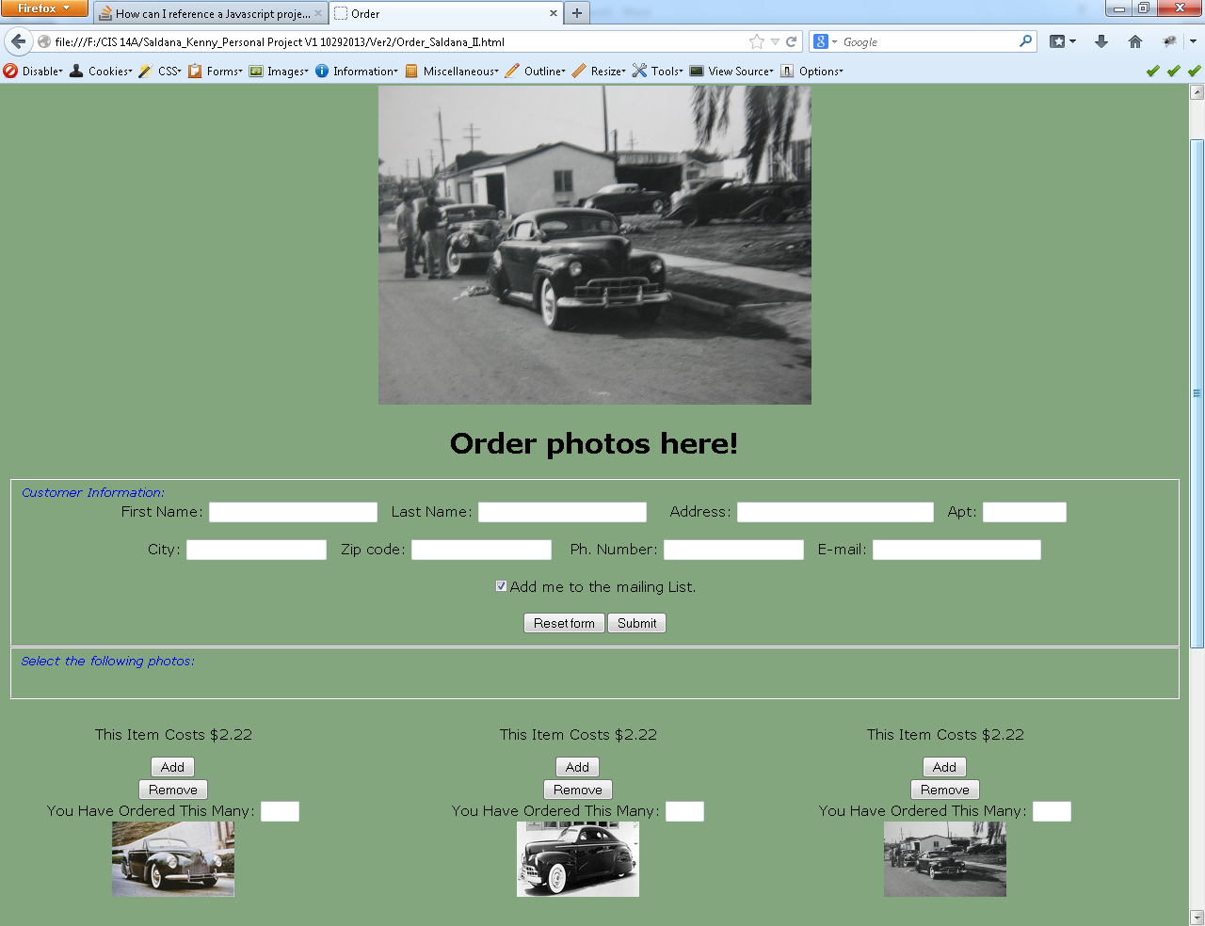

This page was also designed with JavaScript to handle the validation of each data field prior to submission. I’m also utilizing JavaScript to handle the shopping cart aspect of this particular page. Again, the format follows the layout of previous webpages. This page allows users to select any number of posters and the option to select multiple items or remove each item if needed prior to submission.

CSS file was utilized for this webpage design and is proprietary to this page due to the layout. Mentioned in the previous webpage, Order Photo, I decided to create unique CSS files for each of these pages, which helped in gaining more freedom in the layout and to avoid conflicts that was experienced earlier in the design of these webpages.

1. Video

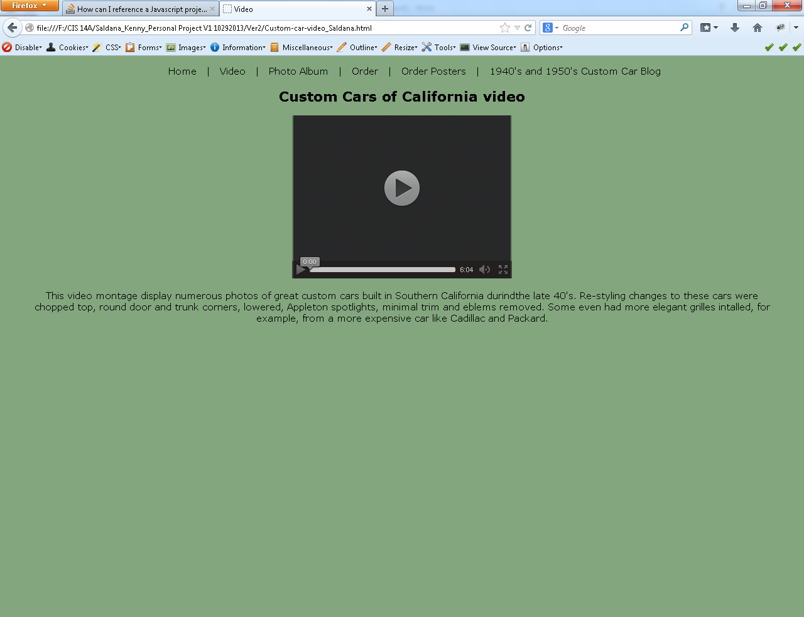

This page plays a video in the MP4 format which is widely used in the vast browsers used by any given customer/user. The idea of this webpage was to provide a collage of the vast photos pertaining to this webpage and is set to jazz, music common during this era.

This page also has a proprietary CSS file to allow unique functionality of the design for this page and further expand this page in the future.